HIGHLAND PARK VICTORIAN
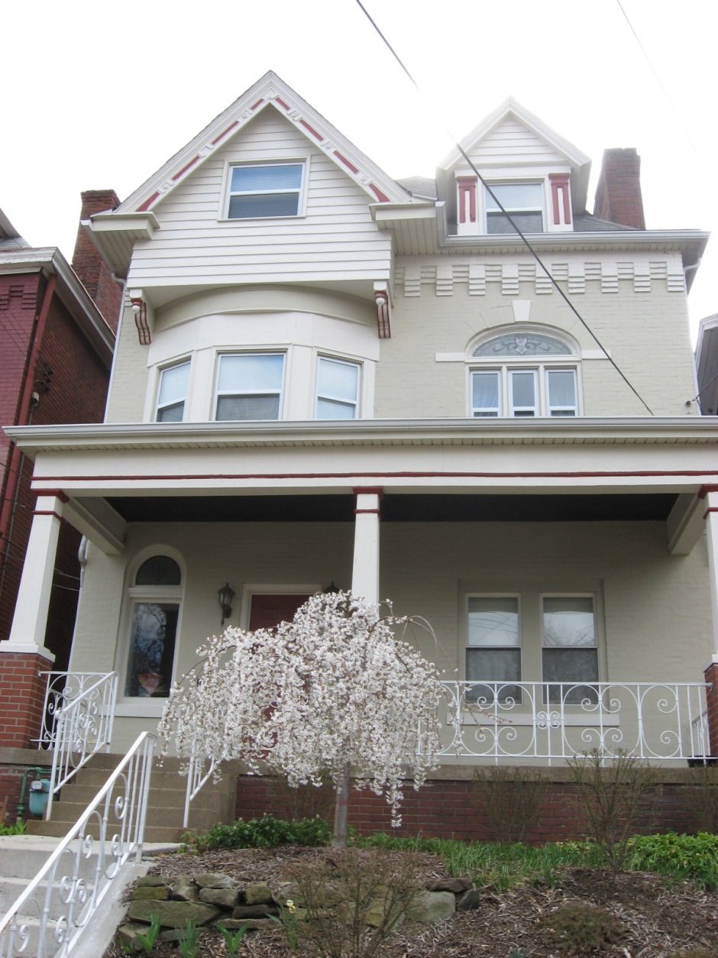
Apartment Available July 1, 2010
- 1 bedroom/ 1 bath $675.00/mth plus electric
- HEAT INCLUDED FREE laundry in the basement
- Large Eat in Kitchen
- Near Whole Foods, East Liberty developments and Park
Call David at 954-857-6302 or
email at ddbinvestments@yahoo.com

