Stamina InMotion E-1000 Elliptical Trainer
$50
Pittsburgh, PA
Small piece cardio workout equipment. Purchased at Walmart for $75 several months ago. Used twice..like new! A description can be found on their website. Takes minimal space!
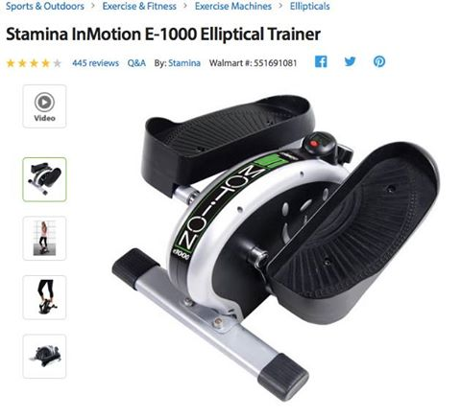

Post to More Places

Like
Show more reactions
Comment

