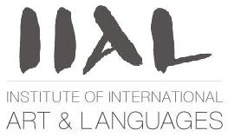
www.instituteIAL.com 724 766 0104

IIAL is pleased to announce 2 weeks
of International summer camp with great activities for the children that will include;
Visual art & craft, Music, Drum, Songs, Dance, Animation,and some Receipes from each foreign country.
When : July 12-16
German 9:00-12:00pm
Spanish 1:00- 4:00pm
July 19-23
Japanese 9:00-12:00pm
French 1:00- 4:00pm
Cost ( including material fees)
1 week program (half day) :$150
1 week program (full day) :$300

To Register call 724 766 0104 or email info@instituteIAL.com

www.instituteIAL.com

SUMMER CAMP REGISTRATION FORM

Child’s name; ……………………………………………………………………………
Date of birth;……………………………………………………………………………..
Address; ……………………………………………………………………..…………………………
……………………………………………………………………………………………………………….............
TEL; ……………………………………………………………………………………………………………………
Email: ………………………………………………………………………………………………………………..
List any allergies: …………………………………………………………………………………………….…
In case of emergency, can IIAL take the child to the children hospital? ……………..
Fees per week (Non refundable):
½ day ; $150 Full day; $300
PARENT’s SIGNATURE:
Make check payable to IIAL, 1135 Mellon street, Pittsburgh PA 15216

