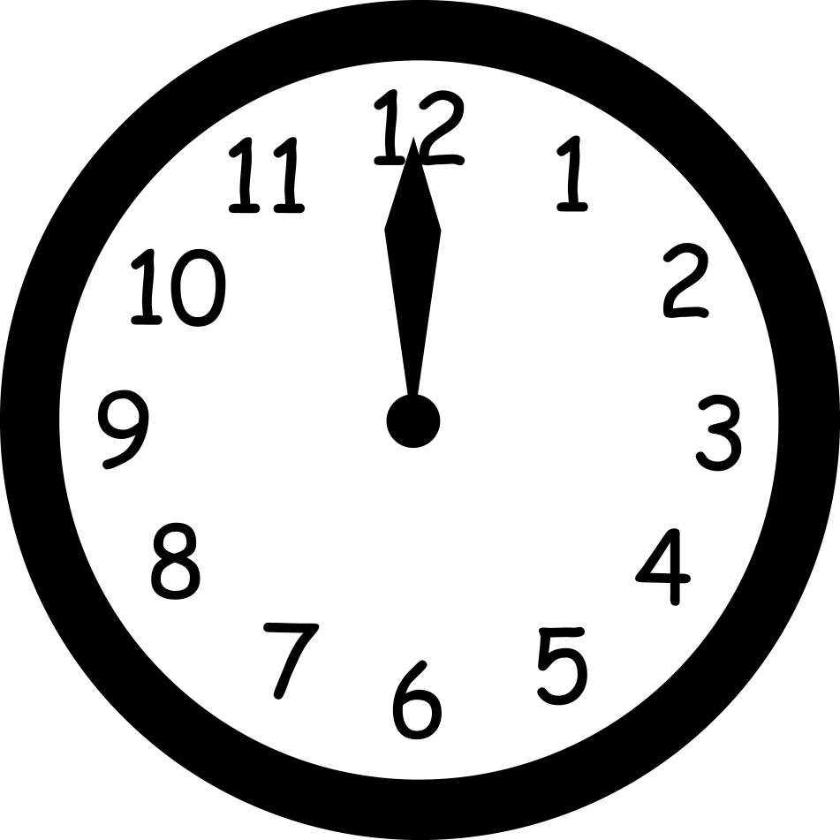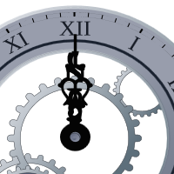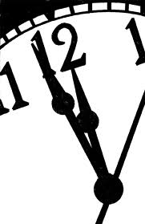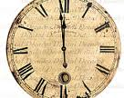

Friday, April 27 at 11 p.m.
Organist Dr. Charles Huddleston Heaton, joined by Soprano Sara Botkin, revives a venerable East End tradition of organ music till the wee hours. Festive reception preceeds the concert at 10:30 p.m.
Music ‘TIL midnight

Saint Andrew’s Episcopal Church
5801 Hampton Street
Pittsburgh, PA 15206
1-412-661-1245

