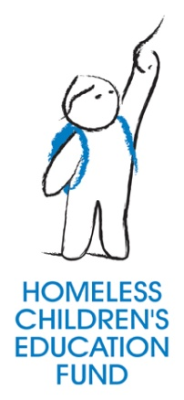
Contact: Zach Marsh, HCEF Event Coordinator
p: (412) 562-0154
e: zmarsh@homelessfund.org

Homeless Children’s Education Fund
2100 Smallman Street - 2nd Floor
Pittsburgh, PA 15222
(412) 562-0154 Phone
(412) 562-1109 Fax
info@homelessfund.org

FOR IMMEDIATE RELEASE
September 12, 2012
Speak Up & Stand Up During the 2nd Annual Homeless Children’s Awareness Week

PITTSBURGH, Pa. – The 2nd Annual Homeless Children’s Awareness Week (HCAW) will take place October 14 – 20, 2012. Many people don’t yet realize the extent and effects of child homelessness.
The purpose of Homeless Children’s Awareness Week is to change that.
Children of all ages are negatively impacted by homelessness in the areas of physical health, emotional and behavioral development, and academic success. Their bright futures are unfortunately hindered by the stress of homelessness, especially if they experience repeated or chronic homelessness.
The McKinney-Vento Homeless Assistance Act states that children are homeless if they lack a fixed, regular, and adequate nighttime residence. This definition includes a large population of children whose families may not know they are entitled to various rights under the McKinney-Vento Act.

The hope for HCAW is to alert families of their rights through the McKinney-Vento Homeless Assistance Act while also encouraging others to get involved in the effort to make a difference in the lives and education of children and youth experiencing homelessness.

We need your help to make the 2nd Annual Homeless Children’s Awareness Week a success across the state of Pennsylvania and the nation. Participate in the events Homeless Children’s Education Fund (HCEF) has already scheduled in Southwestern Pa, or host your own Homeless Children’s Awareness Week event in your community!

To get involved or to list your event, please visit http://hcaw2012.tumblr.com/host-an-event.

This state-wide initiative is being organized by the Homeless Children’s Education Fund that strives to provide advocacy, community engagement, and direct service programs that support the education of children and youth experiencing homelessness in Allegheny County.

About HCEF
Since 1999, the Homeless Children’s Education Fund (HCEF), a 501(c)(3) not-for-profit organization, has been dedicated to providing advocacy, community engagement, and direct service programs that support the education of children and youth experiencing homelessness. For more information, visit www.homelessfund.org.

