MISSING CAT
“Frankie”
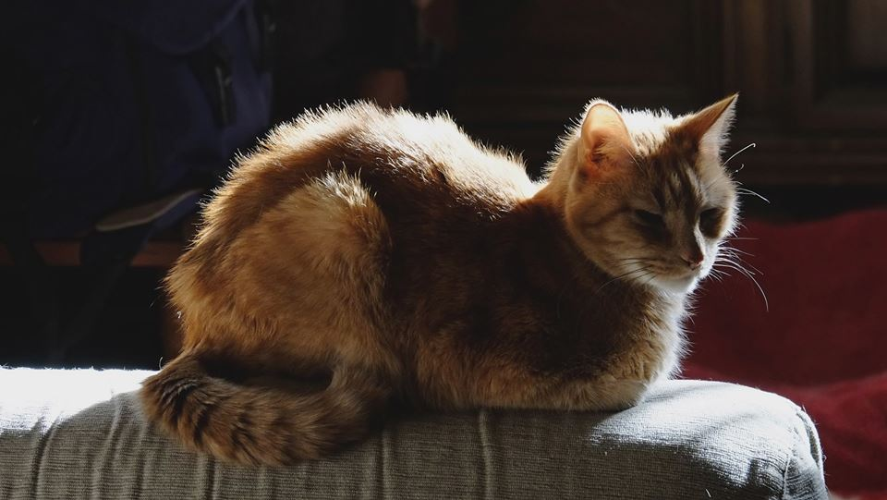
Orange, Short-Haired, 16 yRS
Missing since Wed. PM 1/25/17 from 1124 winterton street
Please call 917-225-5582 or 917-282-4508 if you see him

