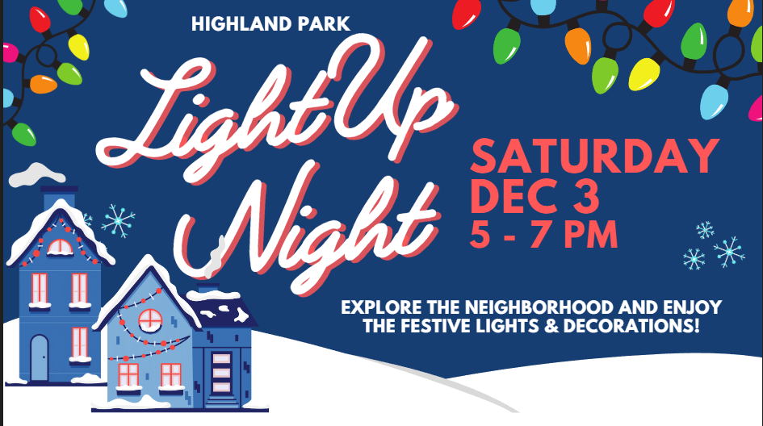
Super Shops (with Light-up Night Specials) & Sparkle Spots
Numbers in “( )” correlate to numbers on the Light-up Night map
*Hard copies of Light-up Maps available at these locations, while supplies last

*(1) Bryant Street Parklet: Winter wonderland photo-ops
(2) Casa Brasil: 5% off take-out with the code "light-up" or 10% off dine-in orders of $50 or more with a paper copy of the Light-up Night map (5904 Bryant Street)
*(3) Panache: 30% off any purchase (5910 Bryant Street)
*(4) Gallery Ama: Free holiday ornaments (1221 Millbrae Way)
*(5) Tazza D’oro: Free brownies & blondies (1125 Highland Ave)
*(6) St. Andrews Church: Free cookies and hot cocoa, plus have your picture taken with St. Nicholas and enjoy the lights and trees in the sanctuary (5801 Hampton Street)
(7) Pittsburgh Theological Seminary: Enjoy the lighted trees out front and help yourself to candy canes that will be there for visitors; cars are welcome to drive through (616 N. Highland Ave)
(8) Winterton Street: Lined with luminaries
Plus treats at (9) 5710 Hampton St. and treats & Santa at (10) 920 Sheridan Ave!
