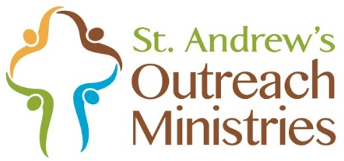

Donations for
Off the Floor Pittsburgh
August 27 — September 17

Bed Linens (new only)
- Sheet sets: twin-, full-, and queen-size
- Blankets: twin-, full-, and queen-size
- Comforters: twin-, full-, and queen-size
You do not have to purchase a complete set for a bed (sheet set, blanket, and comforter). Individual items are welcome!
Please place your donations in a bin at the entrance to St. Andrew’s, Brooks Hall, or the porch of the office building.

