Please Join the Saint Raphael School Community at our
OPEN HOUSE
Sunday, January 27th ~ 12pm
St. Raphael Elementary School (PreK-8th)
1154 Chislett St. in Morningside
Please come if you are a current St. Raphael family, looking for school options for your child, a member of the parish, or just part of the community. Our students are excited to show you around….

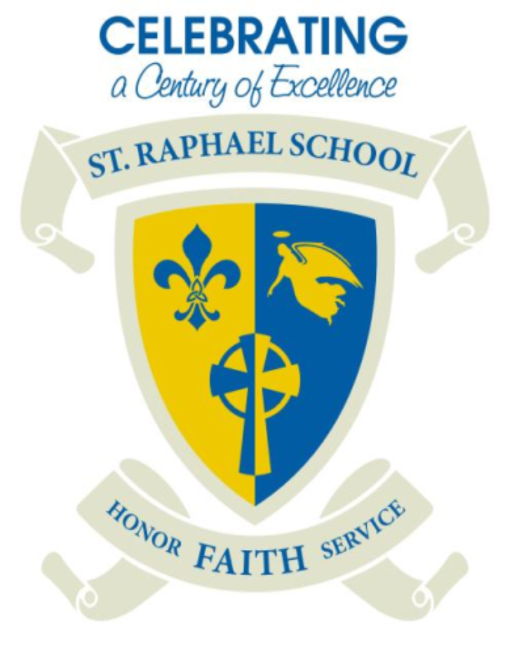
11 AM Mass
Food Trucks serving lunch 12-2 pm!
Gallery style Open House!

