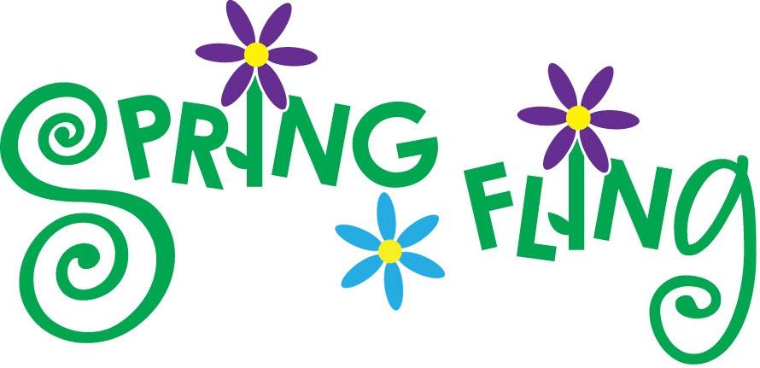

The HPCC is throwing a neighborhood picnic at the Super Playground / Maple Shelter in Highland Park!
Thursday May 16 from 5 – 9 pm

Neighborhood residents are invited to come, relax, and meet their neighbors at this free, fun event! You’ll find:
- Free hot dogs & refreshments, including a cookie table!
- 5 – 7 pm: Kids activities & root beer tasting
plus the Obama Steel Drum Band!
- 7 – 9 pm: Beer tasting - for adults only!
and live music from Smokestack Lightening (bluegrass band)
- Door prizes from Highland Park businesses

Bring a blanket or chairs and be prepared to have fun!

