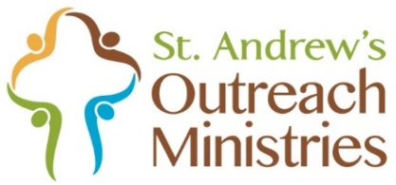

Donations for
East End Cooperative Ministry Food Pantry
March 9—April 13
Non-perishable Foods and Dry Goods
Particularly Requested:
FOOD ITEMS  - Pancake syrup  - Crackers  - Soups/ Broth  - Jelly  - Brand name cereal  - Ramen  - Chef Boyardee Ravioli or SpaghettiO's  - Peanut butter  - Canned vegetables: peas, corn, mixed vegetable, green beans, potatoes  - Canned fruit: applesauce, pears, peaches, apricots, mango, etc.  - Canned fish: salmon, tuna  - Jello & pudding mixes  - Instant mashed potatoes  - Mac & cheese  - Pastas  - Cake mixes and toppings | NON-FOOD ITEMS  - Individually wrapped rolls of toilet paper  - Reusable grocery/tote bags  - Diapers and baby wipes  (many of the 500+ families they serve have infants)  
Bring donations to the blue bin on the front porch of
St. Andrew’s office building by April 13.

