Obama Academy
Is Proud to Present

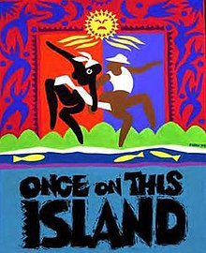

A Middle School and High School Production

Synopsis:
Rich landowners and poor peasants inhabit an island in the Caribbean. Ti Moune is an orphan girl chosen by the gods for a special fate and saved for a special destiny.
It is a story of hope and of inspiration.

“This is why we tell the story…”

Friday, May 3rd and Saturday, May 4th
Friday, May 10th and Saturday, May 11th
7:30pm
515 N. Highland Avenue

Tickets:
https://www.eventbrite.com/e/pittsburgh-obamas-once-on-this-island-tickets-59362539955?fbclid=IwAR1GPhs5C0ATd_p5g8AfeGj0RI9veLrjUlDwmj75ifp2HAxG_WfjqSuWv0Y
$5 student, $8 adult
Snacks for purchase in the lobby
TRT 100 mins.
No intermission

