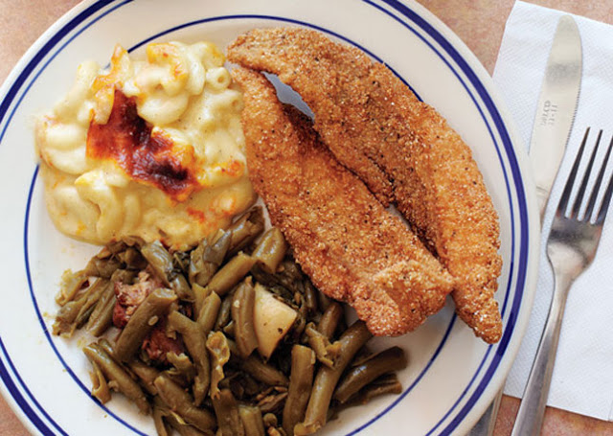

WHEN: FEB. 16TH THRU MAR. 30th (except March 2nd)
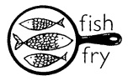
WHERE: VALLEY VIEW PRESBYTERIAN CHURCH
601 North Aiken Ave, 15206 TIME- 3PM – 7PM
Fish Dinner – Fish ,Two sides, roll, dessert, drink - $10.00 Fish Sandwich - $8.00
FOR MORE INFORMATION CALL 412 -361-0870

