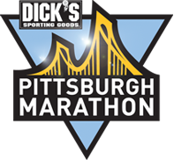
Join Highland Park neighbors and the Highland Park Community Council
for the DICK’S Sporting Goods Pittsburgh Marathon. Help cheer on the
30,000 participants racing through Pittsburgh!
____________________________________________________________________________

Highland Park Cheering Section for the Marathon
Sponsored by the Highland Park Community Council

WHEN: Sunday, May 5, 2024 from 8:00am – 12 Noon
WHERE: The corner of N. Highland Ave & Bryant Street

Come join your friends and neighbors in Highland Park to cheer on the racers of the 2024 Pittsburgh Marathon as they hit the 20-mile mark passing through Highland Park. Racers will enter from the corner of N. Highland Avenue and Bryant Street and run along Bryant Street to N. Negley Avenue.

Live music provided all morning in front of Tazza D’oro coffee shop.

Cheering Section Headquarters – Bryant Street Market Parking Lot
- Free donuts, water and fresh brewed coffee to help kick-start your morning and motivate you to cheer on the racers (while supplies last).
____________________________________________________________________________

Partnering Businesses Include: Bryant Street Market and Tazza D’oro.

