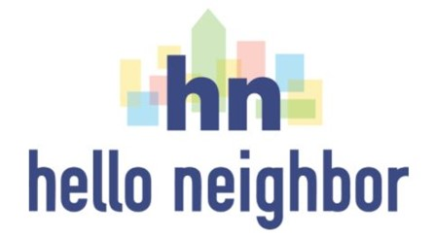
Highland Park/St. Andrew’s
Holiday Collection
for Hello Neighbor

In 2022, Hello Neighbor will be helping 250 refugee and immigrant families to resettle in the Pittsburgh area.

The Highland Park Community Council is collecting the items below for Cleaning Welcome Kits for new families from now through January 9.
- All-purpose cleaner spray
- Dish soap
- Bathroom cleaners
- Kitchen cleaners
- Laundry detergent
- Sponges or cleaning cloths
- Paper towels
- Tissue box
- Trash bags

Please place donations in the bin on the porch of the parish house at St. Andrew’s.

We thank you for making Pittsburgh a
welcoming place for our new neighbors!
