Basil
Variety | Picture | Description | Notes
Cardinal  Newer hybrid, not heirloom | 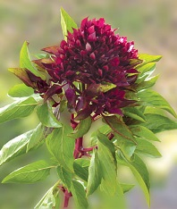 | At last, someone has bred a basil to accentuate the stunning flower heads! Still a culinary basil, but the rich purple flower heads are huge! Use the flowers in arrangements, the leaves in your favorite recipes. Very new and very choice—a milestone of conventional plant breeding!
Genovese |  | Genovese basil grows to heights of 24 to 30 inches and produces large 2- to 3-inch leaves. Flavor is strong and spicy, making it a favorite for pesto and other Italian dishes. This tender annual herb thrives in areas that remain above 50 degrees Fahrenheit and can be grown in containers or directly in the soil.
Greek Dwarf | 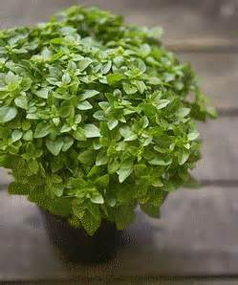 | Cute, compact plants are only 6-inches tall and are great for growing in containers; it has a spicy, slightly anise flavor and is a must for Greek cooking.
Purple | 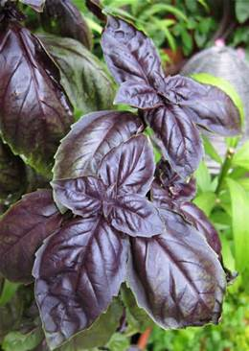 | Purple Basil is a dark, red-leaved basil that is a wonderful addition to any herb garden. Not only is it useful for adding seasoning to Italian and tomato dishes, it's also aromatic and attractive in the garden. Purple basil can be used in any recipe that calls for sweet basil, but until you have tried it, it is best to use slightly less purple basil--the flavor is more intense than traditional sweet basil.
Sweet | 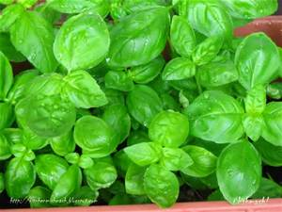 | Sweet Basil (also sometimes called “Common Basil” is the undisputed king of the Italian basils, and one of the most popular herb seeds in the world. As versatile as it is tasty, sweet basil can be used to make just about any dish taste delicious. Plant Sweet Basil nside or out, and use either fresh or dried.

Sweet Peppers
Variety | Picture | Description | Notes
Chervena Chushka  Heirloom | 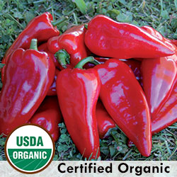 | (Capsicum annuum) (aka Chervena Chujski) Bulgarian heirloom traditionally used for roasting; also delicious eaten fresh. Flesh is sugary sweet. Robust plants produce large tapered fruits measuring 2" wide by 6" long. Fruits ripen from green to brown to vivid red. 85 days from transplant. SWEET. | 85 days
Paradicsom Alaku Sarga Szentes  Heirloom | 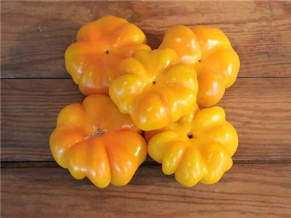 | One of the truly great Hungarian peppers. Yellow, flat, ribbed, pumpkin-shaped fruit have the tremendous flavor that peppers from Hungary are famous for. The flesh is very thick, crisp and juicy. This rare variety was collected at a farmers’ market in Matrafured, Hungary, but developed at Szentes, Hungary | 80 days.
Hot Peppers
Variety | Picture | Description | Notes
Ancho Gigantea  (Poblano)  Heirloom | 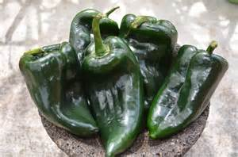 | They are preferred when dried and usually referred to as chile ancho ('wide chile'). When fresh, they ares known as poblano or “pasilla.” The young green pepper is often stuffed with cheese or meat for chiles rellenos, while the dark, reddish-brown dried pepper is used for the traditional "mole poblano" and chili powder. Pepper is heart-shaped, 3.5" long and 2" wide, and is mildly spicy. They are wonderful when roasted and peeled or sliced fresh for a spicy kick in many dishes. Fully ripe peppers are red & sweeter, but can be harvested at any stage. | 80 days.  1,000 – 2,000 Scoville.  Height: 1.5’ – 2’
Habanero  Heirloom | 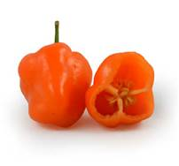 | Among the hottest peppers anywhere! These little peppers look harmless, but use them very sparingly, and remember to wear gloves when handling them, to avoid transferring that heat to your eye!  Blocky, wrinklked peppers measure about 2 inches long and slightly less wide, maturing from silvery-green to bright orange on the plant. Fertilize when blooms appear, and water well. Most nutritious if allowed to ripen on the plant. | 90 days.  100,000 – 350,000 Scoville  Height: 2’ – 3’
Jalapeno  Heirloom | 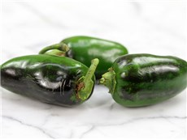 | Perfect for anyone who loves jalapenos, with a thick, flavorful, hot flesh. Great for making salsa. Fruit is 2-3 inches long and about an inch wide when mature.  Pepper plants are self-fruitful and do not even require insects to pollinate them. Just the movement of the blossoms in the breeze will do the trick. They do sometimes have a problem holding their fruit. When growing jalapeno peppers, sprinkle a pinch of Epsom salts on top of the soil just as they come into bloom. This will help the plants to set and hold their crop. | 75 days.  3,000 - 10,000 Scoville  Height: 2’ – 3’
Long Thin Cayenne  Heirloom | 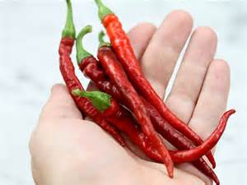 | Slender, long peppers turn bright-red and are very hot. The 2-feet tall plants are vigorous and productive. This heirloom has been popular many years for drying, using as a spice, and also using medicinally. | 70 days.  30,000 - 50,000 Scoville  Height: 1.5’ – 2’’
Tam Jalapeno  Heirloom | 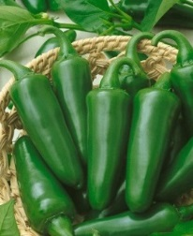 | The Jalapeno has a unique taste, but some find it just a bit too hot. Those (and others!) could try the Tam Jalapeno. This productive variety was developed by the Texas A & M University in the United States and is less hot, but has the same unique flavor as the 'regular' Jalapeno. The plants are slightly smaller and are very resistant to diseases. | 70 days  1,000 Scoville  Height: 1.5’
Tomatoes (Sauce)
Variety | Picture | Description | Notes
San Marzano  Heirloom | 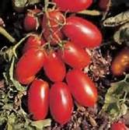 | Plant produces good yields of red tomatoes. These tomatoes are grown on strong robust plants that have leaf protection from strong sunlight. The ripening is graduated throughout the growing season. Excellent for making paste, sauce, puree, and canning. Suitable for home gardens and market growers. A variety from Italy. | 85 days.  Indeterminate.
Super Italian Paste  Heirloom | 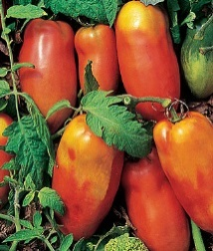 | Reddish-orange 10-oz Italian heirloom with piquant, firm, meaty flesh.  From Italy, with flavor. Primo Italiano heirloom paste tomato produces plenty of elongated, reddish-orange 6" long fruits. Firm and meaty, the flesh is piquant and sweet, ready to star as paste and in sauces. Fruits hold well after ripening on indeterminate vines. | 75 - 90 days.  Indeterminate.

Tomatoes (Pear)
Austin’s Red Pear  Heirloom | 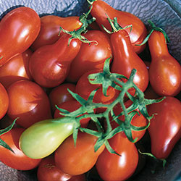 | A real standout among all of SSE’s red pears due to its superior flavor. Large 2" red tomatoes with elongated neck. Very productive. Occasionally a plant with yellow fruit appears. Indeterminate, 80 days from transplant. | 78 days, mid-season  Indeterminate.
Evan’s Purple Pear  New hybrid  Potato-leaf | 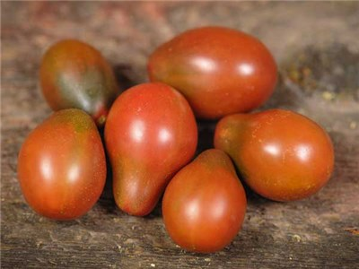 | Also known as Evan’s Purple Plum. Selected from a chance cross from Pruden’s Purple by Brad Gates, released in 2008. Fruits are plum to pear shaped, with an occasional round one. The 2 ounce fruits hang in clusters— very pretty! Flavor is exceptional, one of the best tasting in last year’s trials! Great for sauces, pastes and canning, as well as for fresh use. Potato-leafed plants are vigorous and productive | 78 days.  Indeterminate.
Green Pear | 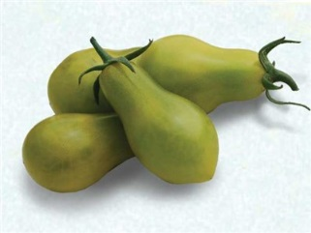 | An outstanding producer of uniform, little, green pear-shaped tomatoes over an extended season. Rich, complex “old-fashioned” tomato taste! Great for salads, canning whole or for market. Tolerates almost any growing conditions. | 78 days.  Indeterminate.
Ivory Pear | 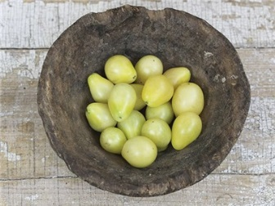 | Cute little 1 oz fruits are ivory-cream in color, shaped like little pears. Plants are very high yielders! Charming when served combined with Yellow or Red Pear types. | 78 days.  Indeterminate.
Umberto Pear | 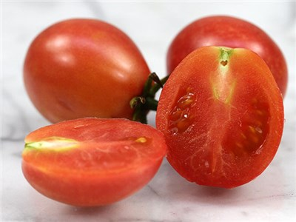 | (also known as King Humbert) Very old Italian heirloom, listed by the renowned French seedhouse Vilmorin-Andrieux in 1885. Named after King Umberto I, King of Italy in the late 19th century. The plants produce unbelievable harvests of small, pear-shaped fruits. These meaty morsels have a nice balance of sweet and tart, with full Old World tomato flavor. Great for paste, sauce or for drying under the late summer sun! | 78 days.  Indeterminate.
Yellow Pear  Heirloom | 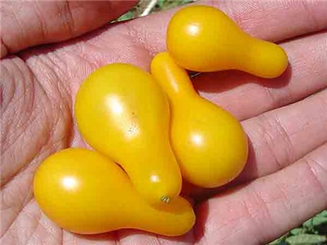 | Very sweet, 1 1/2" yellow, pear-shaped fruit have a mild flavor, and are great for fresh eating or for making tomato preserves. Very productive plants are easy to grow. One of the first tomatoes I grew as a child. | 78 days.  Indeterminate.
Tomatoes (Beefsteak)
Variety | Picture | Description | Notes
Brandywine  Heirloom  Potato-leaf | 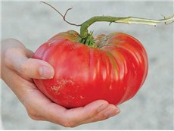 | The most popular heirloom vegetable! A favorite of many gardeners; large fruit with superb flavor. A great potato-leafed variety from 1885. Named after Brandywine Creek in Chester County, Pennsylvania. Large vines produce pink fruits, up to 1.5 pounds each. Very productive. | 80 days.  Indeterminate.  Needs STURDY support.
Hillbilly  Bi-Color  Heirloom | 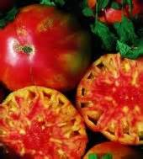 | Undeniably delicious, these enormous, 1-2 pound fruit have gorgeous golden-orange, red streaked flesh and skin. High yielding, indeterminate plants produce sweet, juicy beefsteak type tomatoes that are low in acid and exceptionally tasty in sandwiches and salads | 85 days.  Indeterminate.
Jubilee  Orange  Heirloom | 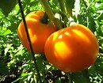 | The eight ounce fruit is bright orange colored, solid, smooth, sweet, with meaty flesh that is not acidic. The plants, although indeterminate, tend to be short-stemmed and stiff. 'Jubilee' makes a unique and attractive tomato juice. It was bred by the W. Atlee Burpee Seed Company and is the result of a stabilized, six-generation selection from a 'Tangerine' x 'Rutgers' cross. An "All-America Selection®" in 1943. | 80 days.  Indeterminate.
Pruden’s Purple  Heirloom  Potato-leaf | 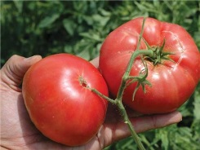 | Lovely deep-pink fruits weigh up to 1 lb. They are early for such large fruit. Similar to Brandywine in size and having the same sweet, rich taste. Potato-leaved plants. | 70 days.  Indeterminate.
Other
Variety | Picture | Description | Notes
Blue Kale |  | One of the most attractive of all vegetables in the fall garden.  Low, compact plants with finely curled, bluish-green leaves. Usually stands winter weather with some protection. Good cooked or fresh in salads. Grows best in cool weather. Can be grown as a spring or fall crop. Harvest all winter to zone 6. | 55 days.  Spacing: 12 inches  Height: 18 inches
Pinto Beans | 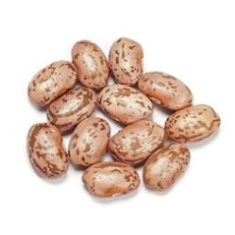 | Vigorous bush type plants that tend to sprawl. Pods are three to four inches long, flat, and green. Can be used for snap beans when young and tender but primarily grown to maturity and used as a dry bean. High in protein, these small speckled brown beans are the most popular dry shell beans for winter use!.Pinto beans are commonly used in Mexican cuisine and great when used for refried beans!. | 85 days.  Sprawling Bush
Cow Pea  Pinkeye Purple Hulled | 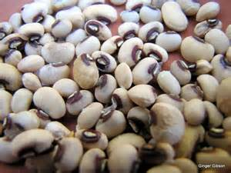 | Bush type plant produces heavy yields of purple pods. Similar to the Purple Hull Pinkeye with same characteristics. Pods contain cream color peas with maroon eyes. Excellent drying and canning variety. A Southern favorite. Suitable for home gardens and market growers. | 65 days  Bush
Romanesco Broccoli  Heirloom | 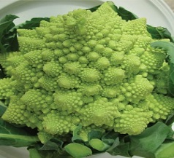 | Romanesco is the preeminent Italian heirloom variety and was first documented in Italy in the 16th century. Its crisp, beautiful apple-green whorled heads impart an altogether pleasing, nutty taste. Most often enjoyed raw, the broccoli, if lightly cooked, will retain its flavor and unique texture. | 75 - 100 days  Height: 2’ – 3’  Spacing: 12 inches
Tomatillo  Gigante Verde | 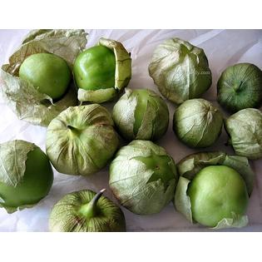 | "South of the border" taste. but has a tart flavor. It is usually used when still green and about the size of a large cherry tomato. The inside is white and meaty. Tomatillos grow inside a thin paper-like husk. They are used in salsa, jams, and other Mexican recipes. | 90-100 days.  Height: 3-4'  Tomatillos are determinate, but top-heavy, so cage or stake.  Pinching recommended.
Aunt Molly’s Ground Cherry  Heirloom | 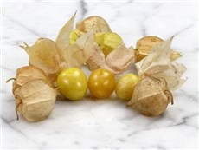 | This is the common type used by the Pilgrims. Ground cherries were recorded as early as 1837 in Pennsylvania. This outstanding Polish variety is prized for its clean flavor. Fruits are 1/2 to 3/4-inch in diameter and encased in a papery husk that turns brown when fruits ripen. Extremely productive plants; fruit has an excellent citrus flavor, and can be used for preserves, pies, over ice cream or in fresh fruit salads. Starts fruiting by the end of July and continues until frost and a little beyond. Excellent results on landscape cloth which suppresses weeds and makes collecting the fruits easy. Fruit grow inside a paper-like husk. | 70 days.  Height: 18” to 24”  Sprawling habit.  Will store 3 to 4 weeks in the husk.
Mystery Eggplant  Heirloom? |  | Eggplant that volunteered in my garden. It might be one of the varieties I grew last year, or it might be a cross between them. There’s just no way to know. Willing to take a chance? | 70 days.  Height: up to 4’. May need to be staked.

