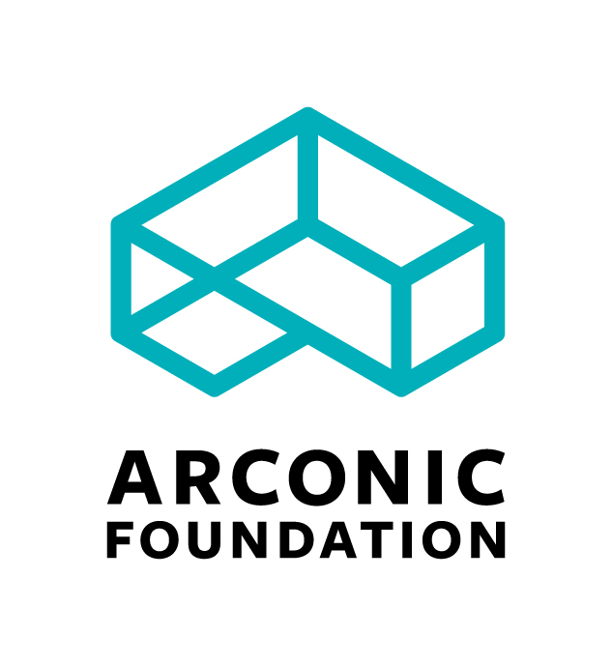
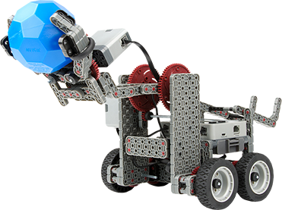
Pittsburgh Urban
Christian School
ROBOTICS CAMP

Intro Camp: June 26th-30th (9am-3pm) students in 4th-8th grades for Fall 2017.

Students will learn RobotC programming fundamentals and engineering concepts and will work with a partner to build and program a robot using sensors to problem solve various challenges throughout the week. The camp will maintain a 2:1 student to robot ratio, so space is limited.

Advanced Camp: August 14th-18th (9am-3pm) students in 4th-8th grades for Fall 2017 and have taken Intro Camp or equivalent experience.

Students will use prior robotics training to meet the challenge of the VEX IQ Game for 2017. Students will use engineering process to strategize and design original robots to tackle the unique challenges of the Vex IQ Teamwork and Skills Challenges.

Cost of each week of camp is $200. Some need-based financial aid may be available upon request. Please apply with attached application.

Please complete the attached registration form at your earliest convenience and return it to the school office or send to the email below.

Contact Jen Moore or Rhonda Smith at pucsrobotics@gmail.com if you have any further questions.
Pittsburgh Urban
Christian School
ROBOTICS CAMP

Registration Form

Student Name: _____________________________________________________________________________

Grade 2017/18:___________ Age: _________ Male:_________ Female:__________

Home Address: _____________________________________________________________________________

_____________________________________________________________________________

Parent/Guardian Name(s): _____________________________________________________________________

Parent/Guardian Contact: Cell: _________________________ Home:___________________________

e-mail _____________________________________________________________________

Emergency Contact: _____________________________________________________________________________

Cell: __________________________________________ Home: ___________________________________________

Allergies or other medical concerns:_____________________________________________________________

Adult Shirt Size: S M L XL Please contact me about Financial Aid

Registering for:

________Intro Camp (June 26th-30th)

________Advanced Camp (August 14th-19th)

_________________________________________________ Date: ____________________________
Signature of Parent or Guardian

Please mail registration form and check, payable to "PUCS" to:
PUCS Robotics Team, 809 Center Street, Pittsburgh, PA 15221.
Questions or concerns: E-mail: pucsrobotics@gmail.com.

