Zone 5 Community Open House
Presenting the 3rd annual
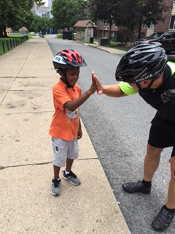
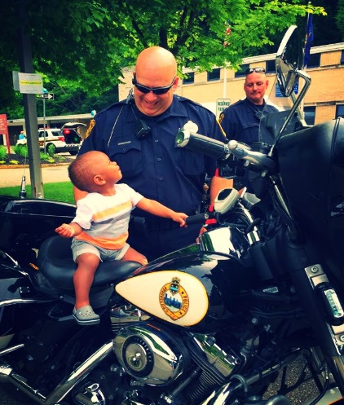
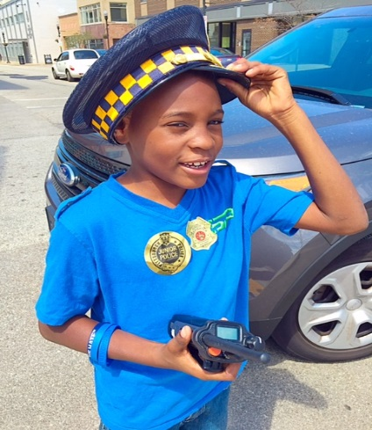
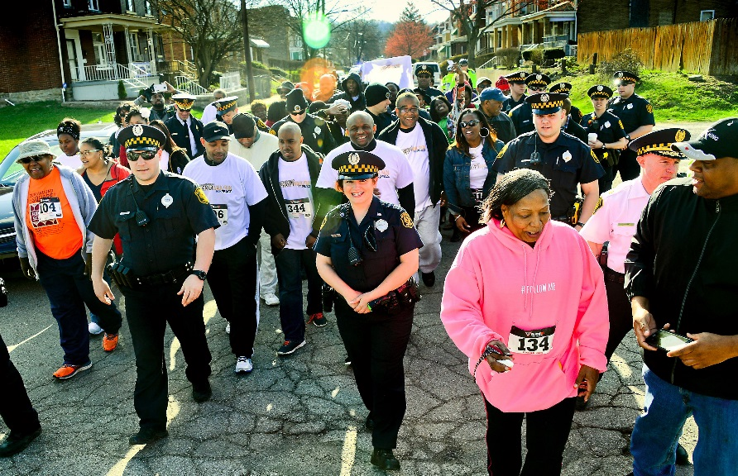
Saturday,
June 3rd
12pm-5pm
No Cost!
Open to All!

- Featuring “DJ” Sgt. Joe Lewis playing your favorite hits.
- Zone 5 officers will be grilling hamburgers and hot dogs.
- Games, face painting, and a magician for the kids.
- We are going to have a “bounce house” for the kids this year!
- PGH Police SWAT and Bomb Squad vehicles on display.
- PGH Police K-9 and Motorcycles on display.
- PGH Paramedics will be on-hand to teach CPR.
- PGH Fire Fighters will be on-hand to teach Fire Prevention.
… And much more!

Location: Zone 5 Station – 1401 Washington Boulevard

