Highland Park (not so) Trivia - ANSWERS
- In what year was the current Highland Park Bridge completed (+/- 5 years)? 1939 (1934 – 1944)
- This “new” bridge replaced a previously existing bridge. Was the old bridge located upstream, downstream or at the current location of the present-day bridge? Downstream

- When was the original bridge built (+/- 5 years)? 1902 (1897 – 1907)

- How many cars does PennDot project will cross the Highland Park Bridge in 2020 (+/- 5,000)?
51,000 (46,000 – 56,000)
- When was the original Highland Park lock and dam built (+/- 5 years)? 1902 (1897 – 1907)

- What is the purpose of the Highland Park dam?
To deepen the river upstream of the Dam to facilitate navigation.

- What are the 4 most prevalent commodities, by weight, going through the lock (one point for each correct answer)?
213,000 tons of Coal (41%)
95,000 tons of Sand and Gravel (18%)
56,000 tons of Iron and Steel (11%)
47,000 tons of Fuel Oil (9%)
- According to the last U.S. Census, what was the population of Highland Park in 2010 (+/- 250)?
6,395 (6,145 – 6,645)
- What year did Highland Park open (+/- 5years)? 1893 (1888 – 1898)
- The statues at the entrance to Highland Park were sculpted in 1896 by a European immigrant. What was his country of origin? Italy
- What Highland Park community asset was the focus of successful integration efforts that began in the late 1940s and early 1950s? Highland Park Swimming Pool
- What 4 neighborhoods border Highland Park?
Morningside
East Liberty
Larimer
Lincoln-Lemington-Belmar
- Where is the highest point in Highland Park?
The small Hill just north of the Reservoir No. 1 (points given for the Reservoir)

- What is the elevation of this point (+/- 100 feet)? 1,086 Feet. (986 feet – 1186 feet)
- What famous Pittsburgher took this picture of swimming lessons at the Highland Park pool circa 1962-1965? Charles “Teenie” Harris
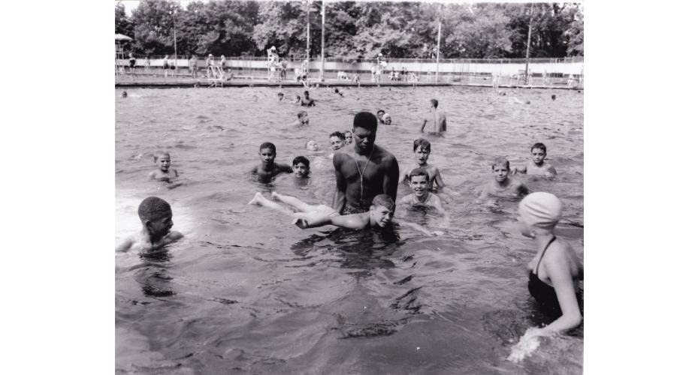
- Historically, Highland Park was largely bounded by the Allegheny River and two streams (neither of which exist in their original form today). What were the name of these two streams? Negley Run & Heth’s Run
- One of the neighborhood’s iconic homes was called “Baywood” when it was built by a European immigrant in 1880. How do Highland Parker’s typically refer to this home today? King’s Estate

- In what industry did the home’s builder make his fortune? Glass-Making
- Where was he born (what country)? Ireland
- We are all familiar with Tazza D’Oro. What business occupied this location before Tazza? Marcus Pharmacy
- There are 3 public schools in/or neighboring Highland Park, each with a specific focus. What are their names and their foci, and who are their namesakes?
Fulton Elementary School - French Emphasis School - Robert Fulton (Developer of Steamboat)

Dilworth Traditional Academy – arts integration and humanities - Dilworth Family (Mary Parry Dilworth, donated the land. Her ancestor William Dilworth is credited with providing a school and teacher on Mt. Washington in the 1820s).

Obama Academy of International Studies – International Baccalaureate – President Obama.

- What famous swing-era jazz singer and bandleader grew up in Highland Park?
Billy Eckstein
- On what street did he live? Bryant Street

