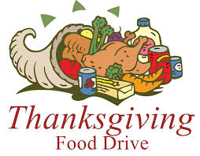

Vintage Senior Center
Thanksgiving Trimmings Bags
Shopping List

- 2 cans of veggies
- 1 can cranberry sauce
- 1 can sweet potatoes
- 1 box stuffing mix
- 1 box instant potatoes, au gratin potatoes, or corn bread mix
- 1 jar gravy
- Either: (A) Two 21-oz jars of canned fruit pie filling, OR
(B) One 15 oz can pumpkin pie filling and one 12-oz can of evaporated milk
- Boxed pie crust mix; either: (A) Two boxes for fruit fillings, OR
(B) One box for pumpkin pie fillings
Donations must be dropped off on the porch at 1315 N. Sheridan Ave. by 5 pm, Thursday, November 12. If possible, please put all items for a basket in a double-bagged brown paper grocery bag with handles.

Giant Eagle gift cards are also appreciated. $25 will pay for an entire trimmings bag for a senior household but donations of any size are appreciated! Questions? Email Stephanie at HPCCPgh@gmail.com.

Thank you for your generosity and Happy Thanksgiving!

