2bdrm, 1 bath, $1145/mo incl heat, a/c, water available August 1, 2016
Hope you look at this apartment available for rent on August 1, 2016. 2 bd, 1 bath for $1145, including heat, a/c and water at Parklane Apts, 5700 Bunkerhill Rd, Highland Park, PGH, 15206. It’s nice sized, great location, SW corner of the building with lots of window space - sunsets. Ask for Apt 904. Mozart rentals. Save money by sharing with another student. My friend leased this apt when her house was for sale - sale fell through and if it isn't re-rented, she will be stuck with rent and her continued mortgage. So, if you might be interested, it would be awesome to help her out.
LaneProperty ManagerMozart Management412-682-7000http://www.mozartrents.com
Lane Sampson
Property Manager
Mozart Management
412-682-7000
http://www.mozartrents.com
- heat, water, sewage, hot water, and trash included in rent  - carpet and ceramic or hardwood laminate and ceramic  - air conditioning  - refrigerator  - dishwasher  - full sized electric stove with oven  - full bath tub with shower  - pet friendly  - apartments may vary slightly | Floor Plan in PDF(printable) format  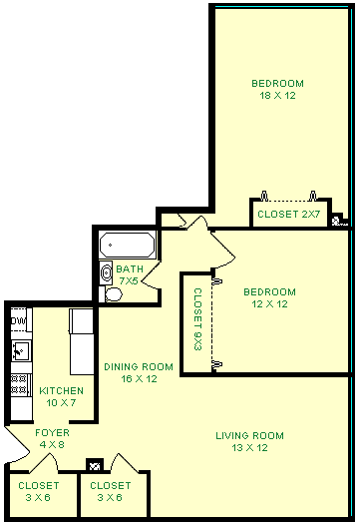
  Sq. Ft. | 1050
  Baths | 1.0
  Bedrooms | 2
  Monthly Rent | $1,145
  Availability Dates
  Aug 01, 16
