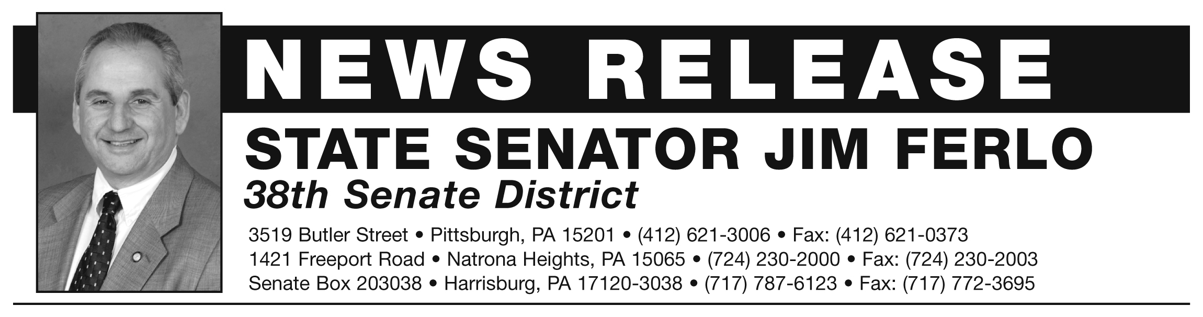SENATOR JIM FERLO CONTACT: Anne Huber

PHONE: (412) 621-3006 or (412) 952-3364 PHONE: (717) 787-6123
jferlo@pasenate.com ahuber@pasenate.com

Senator Ferlo introduces bill to overhaul oil and gas regulations

Harrisburg, April 29, 2014 – State Senator Jim Ferlo (D-Highland Park) announced the introduction of Senate Bill 1359 that will overhaul key requirements of the statute which regulates oil and gas drilling in the Commonwealth; often referred to as Act 13. Ferlo’s legislation includes several improvements to the existing law, including amendments that will impose a reasonable Marcellus Shale severance tax, strengthen environmental and public health protections, and protect the restoration of local zoning powers.

“Act 13 of 2012 has numerous shortcomings, some of which have recently been successfully challenged in court, and my bill hopes to right some of these wrongs. The current law fails to protect public health and safety, falls short on covering the actual costs of drilling, and undervalues the natural gas the Commonwealth can produce; all issues that my bill addresses,” Ferlo explained.

Ferlo asserts that the gas drilling industry in Pennsylvania continues to bring in unprecedented profit during a state-level budget crisis; the result of their powerful lobby. The public has been forced to tolerate Governor Corbett’s decimation of the education system and social safety net while Marcellus Shale drillers fill their pockets, and Ferlo believes that a severance tax that helps to close Pennsylvania’s budget shortfall is the best course of action.

“My legislation will bring in $775 million in badly needed revenue, estimated based on the Commonwealth’s natural gas production numbers from last year. Pennsylvania has the lowest effective tax rate of any state in the nation, and the Republican majority is leaving revenue on the table,” Ferlo said.

Ferlo expressed additional concerns with the current impact fee charged on oil and gas drillers. Act 13 of 2012 left Pennsylvania poorly protected from the everyday impacts of the gas industry. The existing fee does not compensate the Commonwealth appropriately for the local effects on roads and social services, nor pay for the damage done to the environment. The infrastructure all Pennsylvanians rely on is crumbling as a result of the industry.

“The local fee component in the law is insignificant and grossly undersells Pennsylvania’s Marcellus shale resources,” Ferlo said. “My legislation would do away with this inadequate fee structure, and impose a more robust severance tax similar to every other major gas producing state in America.”

The bill also repeals the reckless statewide zoning provisions imposed by Act 13. The bill would once again empower local municipalities to control land use policies. Earlier this year, the Pennsylvania Supreme Court overruled the local zoning portion of Act 13 as unconstitutional because it violated the Environmental Rights Act amendment. The bill would reestablish what had been practice for decades; allowing local residents and governing bodies to make the best decisions for their communities.

Ferlo’s plan also includes requirements that drillers must notify an expanded area of local property owners and municipalities prior to drilling; creates new boundaries at drilling sites to be used for measuring distances from residences, educational, and medical facilities; provides that water management plans must include considerations for wildlife and ecosystems; clarifies that doctors should have immediate access to any and all information pertaining to patients’ medical conditions and can share that information; increases criminal penalties for violating the act; and creates a two-year moratorium on any additional leasing of state forest lands for drilling.

A complete and detailed list of the amendments proposed in Senate Bill 1359 is attached. The bill is currently awaiting referral to the appropriate Senate committee.

###

State Senator Jim Ferlo is a Democrat representing the 38th Senatorial District comprised of parts of the City of Pittsburgh, Armstrong, and Westmoreland Counties. Senator Ferlo serves constituents in two district offices; one in Lawrenceville and one in Natrona Heights. For more information, visit www.senatorferlo.com
1. Eliminates the impact fee and replace it with a fair severance tax of $0.25 per thousand cubic feet of gas. The tax rate will adjust up as the price of gas increases and will be collected by the Department of Revenue. If the tax had been in place in 2103 it would have raised $750 million.

2. The existing funding distribution formula will remain the same for the first $200 million. All additional funding will be directed to the General Fund.

3. Require that a driller of an unconventional well provide notice to surrounding property owners and municipal officials that are within 5,000 ft of the well site prior to the well drilling permit application being submitted to the Department of Environmental Protection (DEP).

4. Utilizes the edge of the well pad as the boundary to begin all measurements for required distances for notification instead of the bore hole.

5. Provides that, in a water management plan, potential damage to ecosystems and wildlife must be a consideration in the approval process.

6. Provides set backs from the edge of the well pad of 1,500 feet from buildings, 2,500 feet from drinking water sources, 1,000 feet from exceptional value water sources, and 500 feet from any other body of water and eliminates the Department of Environmental Protection’s ability to waive these requirements. It also prohibits drilling with the boundary of a wetland.

7. Adds proximity to water sources, including trout streams and wetlands, as conditions for the DEP to consider when reviewing a well application and would further allow the Department to deny or condition the permit based on 7 possible impacts.

8. Improves the standards of drinking water that a driller must obtain to replace lost drinking water that is contaminated due to drilling activity.

9. Amends how trade secrets are handled by the Department in relation to public access.

10. Clarifies that doctors shall have immediate access to any and all information that might be related to a patient’s condition, and that the doctor is free to share that information with the patient, a county or state department of health, or other health agency or association.

13. Requires that first responders may obtain the drilling report information for any well to which they are responding in an emergency, including proprietary information, regarding the fracking solution.

14. Increases bonding requirements.

15. Increases criminal penalties related to violations of the act.

16. Deletes Chapter 33 (Local Ordinances Relating to Oil and Gas Operations) and restores zoning and land use decisions to municipalities.

17. Creates a moratorium on any additional leasing of state forest land for 2 years.

