Used Baby Items for Sale (all in very good condition)

Carriers
Baby K’Tan (Small, Gold/Brown), $25
Baby K’Tan Active (Small, Blue/Turquoise), $25
Baby K’Tan (Small, Black), $25
Baby K’Tan (Large, Grey), $25
Maya Ring Sling (Lightly padded, Navy Blue), $25

Other
BabyBjorn Bouncer (black mesh) + toy bar, $100
Babyletto mini crib (with mattress), $50
Boon Lawn Countertop Drying Rack, $10
Mylittleseat Travel Highchair (Biggy Buttons), $5
Pehr felt circus performers mobile, $30
Bebe au Lait cotton nursing cover (pattern not online), Free

Swaddles/sleep sacks
Halo sleep sack swaddle (Small Cream (2), Blue polar fleece), $10 each (3 available)
Halo sleep sack (Small, grey elephant), $10
Miracle blanket swaddle (cream, grey, white with blue trim) (3 available), $10 each
Love to Dream swaddle (Medium, Small, both dusty blue) (2 available), $10 each
Woombie original swaddle (Newborn, lime green), $10

Clothing
MagnetMe onesies - great for frequent newborn diaper changing, 0-3 months, $10 each (boats, dinosaurs) 2 available

Complete newborn/0-3month set of clothes, (boy oriented but could easily work for a girl), $75 for whole set
- Brands include Burt’s Bees, Kickee, KissyKissy, Gap, Carters, and others
- 15+ onesies with feet, 5+ onesies without
- 10+ pairs of pants
- 10+ short-sleeved shirts
- 7 long sleeve shirts
- 2 sweaters/sweatshirts
- 5+ hats
- 5+ pairs of shoes including a pair of FreshlyPicked moccasins
- Bag of infant socks 16+ pairs
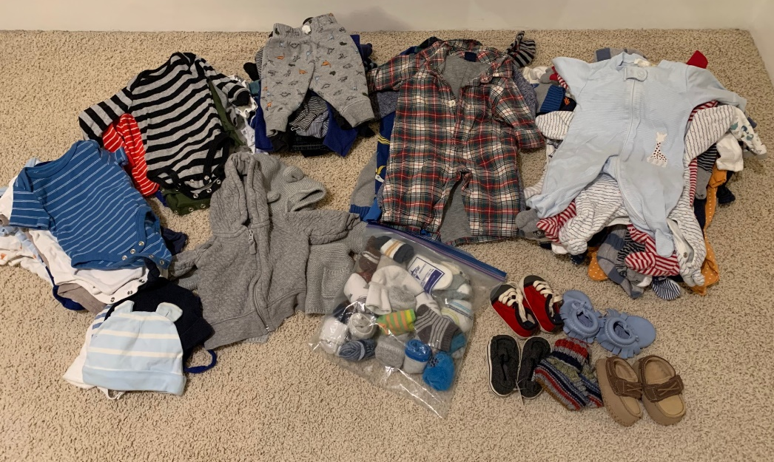

Complete newborn/0-3month set of clothes, (girl oriented but who says boys can’t wear pink!), $75 for whole set
- Brands include Burt’s Bees, KissyKissy, Gap, Carters, and others
- 10+ onesies with feet, 5+ onesies without feed
- 10+ short-sleeved onesies shirts
- 10+ pairs of pants
- 5 long sleeve shirts
- 2 hats
- 2 sweaters/sweatshirts
- 1 pair of overalls, 1 button-down shirt, one eggplant onesie
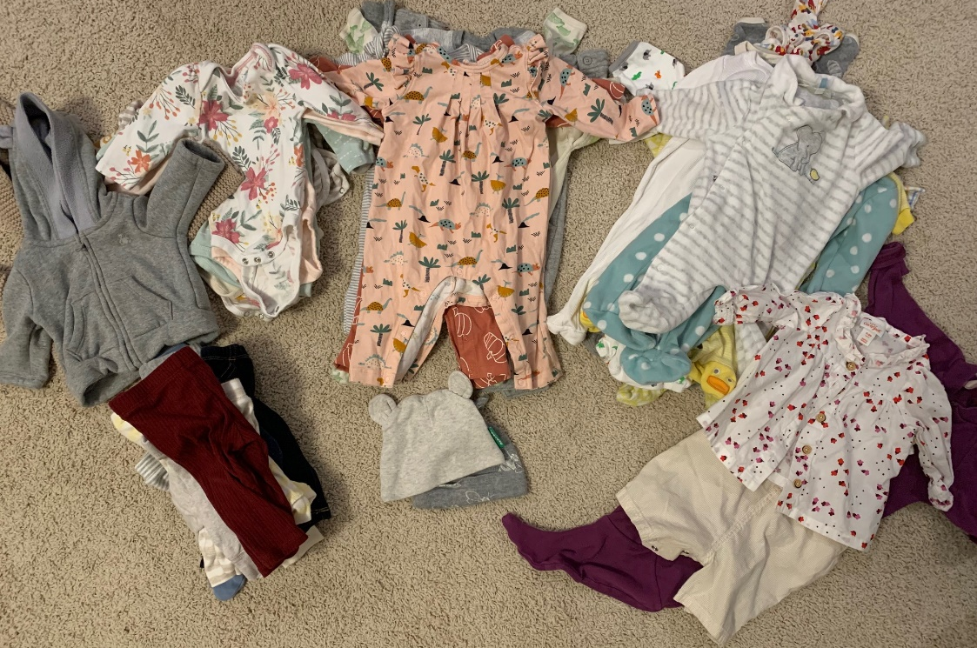

Complete 3-6 month set of clothes, (boy oriented but could easily work for a girl), $75 for whole set
- Brands include Burt’s Bees, KissyKissy, Janie and Jack, Oshkosh, Cat and Jack, Gap, Carters, and others
- 20+ long sleeved onesies with feet plus 5 button-down collared shirt onesies
- 30+ short sleeved onesies shirts plus 7 collared shirt short sleeved onesies
- 10+ long sleeved onesies shirts
- 20+ pants
- 7 overalls
- 3 hats
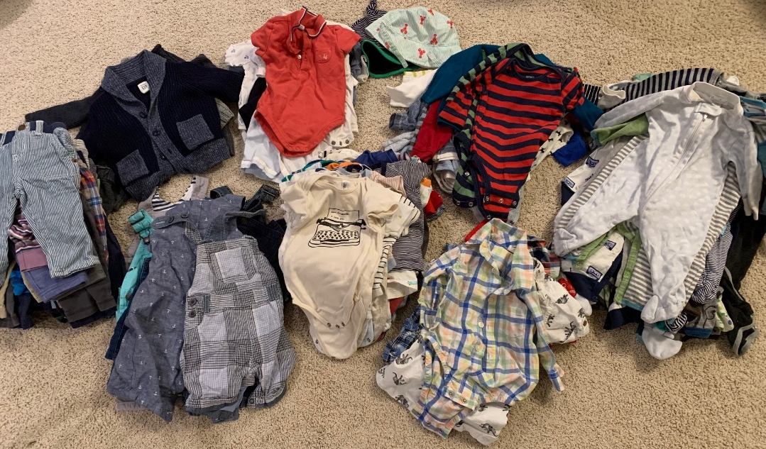
Complete 3-6 month set of clothes, (girl oriented but who says boys can’t wear pink!), $75 for whole set
- Brands include KissyKissy, Gap, Cloud Island, Carters, and others
- 15+ long-sleeved onesies with feet plus 2 short sleeve short onesies
- 15+ short-sleeved onesies shirts
- 15+ pairs of pants
- 5+ long sleeve shirts
- 5 overalls
- 5 sweaters/sweatshirts, 1 fullbody sweatshirt
- 1 dress
