Highland Park Neighborhood Outreach

To benefit the families of
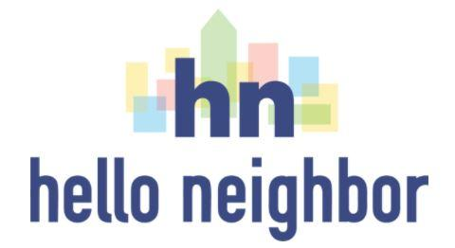

Hello Neighbor is a Pittsburgh-based nonprofit organization
committed to supporting our newest neighbors,
recently resettled refugee families.

With the devastating effects of COVID-19, our
Hello Neighbor families need your support more than ever.

Please consider gifting our families
the essential items they need
Donation list is on the reverse side of this flyer.

Donation Barrels
will be placed on the Rectory porch at
St. Andrew’s Episcopal Church
5801 Hampton Street
Daytime hours, December 1 through January 15
Highland Park Neighborhood Outreach
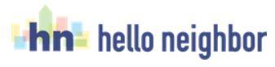
Family Donations List

All items must be NEW.
We are looking for items for both children and adults.

Items Needed:
- Diapers + wipes
- Shampoo + conditioner (full size bottles only, please)
- Soap (full size only, please)
- Deodorant (full size only, please)
- Body lotion (full size bottles only, please)
- Toothbrushes + toothpaste (full size tubes only, please)
- Feminine hygiene products (pads preferred)
- Cleaning supplies
- Handheld vacuum cleaners
Donation Barrels on St. Andrew’s Rectory Porch
5801 Hampton Street

A Highland Park Community Project
Sponsored jointly by
Highland Park Community Council and
St. Andrew’s Episcopal Church Outreach Ministries

