BASIL
Variety | Picture | Description | Notes
Cardinal  Basil  HYBRID | 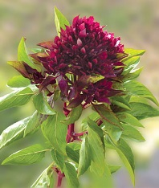 | At last, someone has bred a basil to accentuate the stunning flower heads! Still a culinary basil, but use in arrangements, and the leaves in your favorite recipes. Very new and very choice—a milestone of conventional plant breeding!
Genovese  Basil  Heirloom |  | Genovese basil grows to heights of 24 to 30 inches and produces large 2- to 3-inch leaves. Flavor is strong and spicy, making it a favorite for pesto and other Italian dishes. Can be grown in containers or directly in the soil.
Greek Dwarf  Basil  Heirloom | 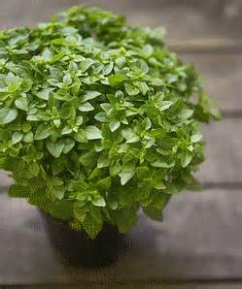 | Cute, compact plants are only 6-inches tall and are great for growing in containers; it has a spicy, slightly anise flavor and is a must for Greek cooking.
Holy Kaprao  Basil  Heirloom |  | A popular herb in Thai cuisine, The fragrant green leaves can be used in potpourri and have a spicy, sweet, clove-like flavor. A religious herb of the Hindus.
Purple  Basil  Heirloom | 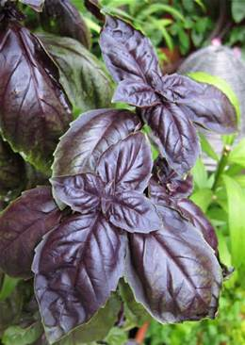 | Purple Basil is not only is it useful for adding seasoning to Italian and tomato dishes, it's also aromatic and attractive. It can be used in any recipe that calls for sweet basil, but use slightly less--the flavor is more intense than sweet basil.
Sweet  Basil  Heirloom | 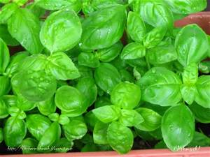 | This is the undisputed king of Italian basils. As versatile as it is tasty, sweet basil can be used to make just about any dish taste delicious. Plant inside or out, and use fresh or dried.

SWEET PEPPERS
Variety | Picture |  | Description | Notes
Romanian  Heirloom | 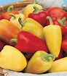 |  | These beautiful peppers mature from a nice ivory color, to orange, to red. Frequently you'll see all three colors on the plant at the same time. They have a thick flesh and are very sweet. | 75 days.
Cubanelle  Heirloom | 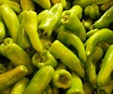 |  | Cubanelle is a thin-walled, long, tapered pepper with more flavor and a lower water content than other bell peppers. It's best picked when yellow-green for use in roasting or frying but can also be left to mature when it will turn orange-red. | 70 – 80 days.
HOT PEPPERS
Variety | Picture |  | Description | Notes
Poblano (Ancho)  Chile  Heirloom | 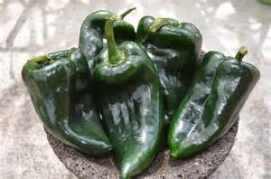 |  | Great for chiles rellenos. When dried, referred to as ancho, which is reddish-brown and used for "mole poblano" & chili powder. Pepper is heart-shaped and mildly spicy. Fully ripe peppers are red & sweeter, but can be harvested at any stage. | 80 days.  1,000 – 2,000 Scoville.
Jalapeno  Heirloom | 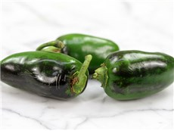 |  | Thick, flavorful, hot flesh. Great for salsa. Fruit is 2-3 inches long and about an inch wide when mature. Plants are self-fruitful. | 75 days.  3,000 - 10,000 Scoville
Long Thin Cayenne  Heirloom | 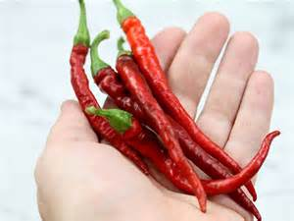 |  | Slender, long peppers turn bright-red and are very hot. The 2-feet tall plants are vigorous and productive. This heirloom has been popular many years for drying, using as a spice, and also using medicinally. | 70 days.  30,000 - 50,000 Scoville
Tam Jalapeno  Heirloom | 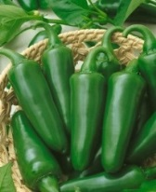 |  | Tam Jalapeno is a productive variety developed by the Texas A & M University and is less hot, but has the same unique flavor as the 'regular' Jalapeno. The plants are slightly smaller and are very resistant to diseases. | 70 days  1,000 Scoville
SNACKING TOMATOES
Variety | Picture | Description |  | Notes
Austin’s Red Pear  Heirloom | 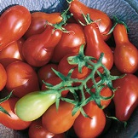 | A real standout among red pears due to its superior flavor. Large 2" fruits with long neck. Very productive. Occasionally a plant with yellow fruit appears. Indeterminate. |  | 78 days, mid-season  Indeterminate.
Evan’s Purple Pear  HYBRID | 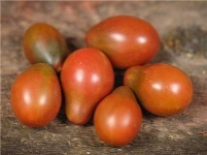 | Plum to pear shape, occasionally round. Clusters of 2-oz fruits. Exceptional flavor! Great for sauces, pastes and canning, as well as fresh use. Potato-leafed, vigorous & productive. Indeterminate. |  | 78 days.  Indeterminate.
Green Pear  Heirloom | 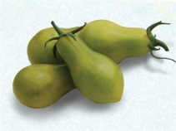 | Outstanding number of uniform, pear-shaped tomatoes over an extended season. Rich, complex “old-fashioned” tomato taste! Great for salads or canning whole. Tolerates almost any growing conditions. Indeterminate. |  | 78 days.  Indeterminate.
Ivory Pear  Heirloom | 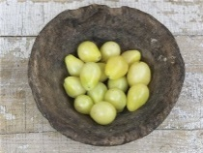 | Cute 1-oz fruits are ivory-cream and shaped like little pears. Plants are very high yielders! Charming when served combined with Yellow or Red Pear types. Indeterminate. |  | 78 days.  Indeterminate.
Sunsugar  F1 HYBRID | 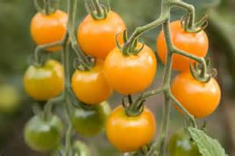 | A medium-sized, orange ripening cherry tomato, sought after for its intense sweet flavor. The fruits grow to a bit under an inch wide, with a thin skin that is very crack resistant. Sun Sugar plants fruit in huge quantities, with a single plant often bearing hundreds of fruits in a single season. The fruits have decent storage capabilities, generally lasting off the vine for 1-2 weeks. Flavor is highly sweet, with fruity overtones, setting the Sun Sugar apart from many of its red counterparts. Plants are vigorous and may grow to 6-7ft, though it will fruit nicely in containers. |  | 60 - 65 days.  Indeterminate.
Umberto Pear  Heirloom | 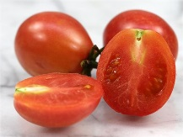 | Pink Italian heirloom, listed in 1885. Named after King Umberto I, of Italy. Old World tomato flavor: meaty with a nice balance of sweet and tart. Unbelievable harvests! Great for paste, sauce or for drying. Indeterminate. |  | 78 days.  Indeterminate.
Yellow Pear  Heirloom | 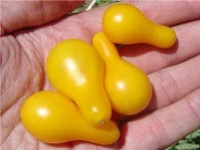 | Very sweet, 1 ½ " pear-shaped fruit. Mild flavor, great for fresh eating or making tomato preserves. Very productive. Indeterminate. |  | 78 days.  Indeterminate.

BEEFSTEAK (SANDWICH OR SLICING) TOMATOES
Variety | Picture | Description | Notes
Brandywine  Heirloom | 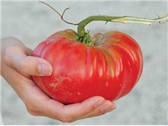 | The most popular heirloom vegetable! A favorite of many gardeners; large fruit with superb flavor. A great potato-leafed variety from 1885. Named after Brandywine Creek in Chester County, Pennsylvania. Large vines produce pink fruits, up to 1.5 pounds each. Very productive. Indeterminate. | 80 days.  Needs STURDY support.
Variety | Picture | Description | Notes
Gigante Verde  Heirloom | 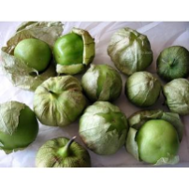 | "South of the border" taste. but has a tart flavor. It is usually used when still green and about the size of a large cherry tomato. The inside is white and meaty. Tomatillos grow inside a thin paper-like husk. They are used in salsa, jams, and other Mexican recipes.  Tomatillos are determinate, but top-heavy, so cage or stake. Pinching recommended. | 90-100 days.  Needs STURDY support.
Purple  Heirloom | 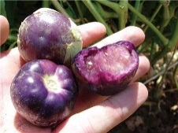 | Beautiful purple fruit, large size. Many are a bright violet color throughout their flesh. Much sweeter than the green types; it can be eaten right off the plant. Turns purple when ripe; rare! | 90 days
OTHER TOMATO COUSINS
Variety | Picture | Description | Notes
Aunt Molly’s Ground Cherry  Heirloom | 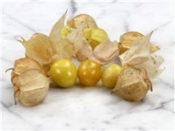 | This outstanding Polish variety is prized for its clean flavor. Fruits are 1/2 to 3/4-inch in diameter and encased in a papery husk that turns brown when fruits ripen. Extremely productive plants; fruit has an excellent citrus flavor, and can be used for preserves, pies, over ice cream or in fresh fruit salads. Starts fruiting by the end of July and continues until frost and a little beyond. Fruits grow inside a paper-like husk. | 80 days.
Garden Huckleberry | 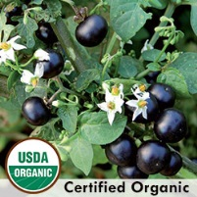 | (Solanum melanocerasum) Upright 3-4' branched plants produce hundreds of ¾" metallic purple-black berries in clusters. Best when picked after berries turn from glossy to dull black. Tasteless when raw and unsweetened, but can be made into delicious mock blueberry pies and preserves. Use about 1 pound of berries to ½ cup of sugar for best flavor. Good for freezing and canning. | 75 - 80 days.
OTHER
Variety | Picture | Description | Notes
Blue Kale |  | One of the most attractive of all vegetables in the fall garden.  Low, compact plants with finely curled, bluish-green leaves. Usually stands winter weather with some protection. Good cooked or fresh in salads. Grows best in cool weather. Can be grown as a spring or fall crop. Harvest all winter to zone 6. | 55 days.  Spacing: 12 inches  Height: 18 inches

