Starry Sky Farm
Pasture-raised Lamb - Pre-Orders
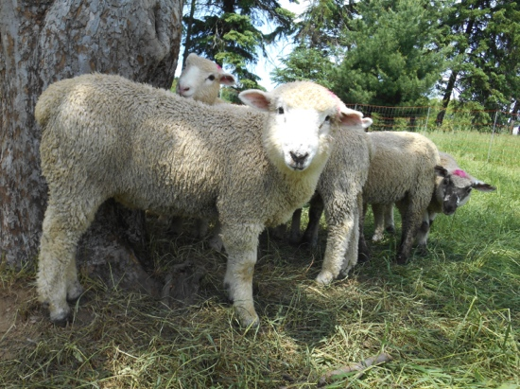
Starry Sky Farm is taking orders for pasture-raised lamb, grass-fed and grass-finished, from spring-born lambs that will be ready in the fall. Lambs are humanely and sustainably raised on beautiful pastures, and free of hormones or antibiotics.

How does it work?
Lamb frozen and packaged will be ready for pick-up in the fall. Reserve a half or whole lamb by sending a deposit ($40 for half, $60 for whole) with an order form. Standard cutting will be done, with chops at 1” thickness. All lamb will be professionally wrapped and frozen at a licensed facility. You will be informed of a date and a location for pick-up (either in Pittsburgh East-End or Butler) when the lamb is ready in October.
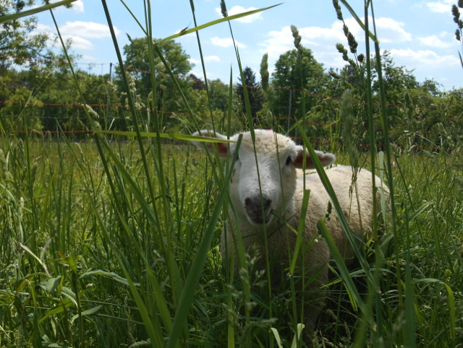
How much does it cost?
Price is $10 per pound hanging weight, which is the step just before the meat is divided into the familiar retail cuts we cook with. Average weights run 40-43 lbs hanging weight, so totals are approximately $400 for a whole lamb, or $200 for a half. Some lambs are smaller, some larger. We’ll let you know your total due once the lamb is weighed and ready for pick-up.
Interested in Starry Sky Farm products?
Join our mailing list by emailing: farm@wholechoice.net to get info about pasture-raised meats and other products.
S.N.A.P.BENEFITS ACCEPTED!
Starry Sky Farm
Starry Sky Farm LLC uses sustainable, time-honored and cutting-edge (yes, both!), farming and animal husbandry methods to care for the land on which it operates and produce healthful and nurturing food – for neighbors and communities in southwestern Pennsylvania. Starry Sky Farm uses local processing, services, and sells direct to consumers in our region.

Starry Sky Farm farm@wholechoice.net, ph 412-450-8242 / cell 503-956-4736
------------------------------------------------------------------------------------------------------------------------------------------------------------------------------------------------------------------------Pasture-raised Lamb - Order Form 2015

Name ________________________________________________________________

Address ______________________________________________________________

Phone ____________________________alternate_____________________________

Email _________________________________________________________________

Amount ordered: _______ Whole Lamb(s) @ $60 each deposit non-refundable

_______ Half Lamb(s) @ $40 each deposit non-refundable

Please make checks payable to “Starry Sky Farm LLC” Mail form & check to: 1 Highland Court, Pittsburgh, Pennsylvania 15206
Ph 412-450-8242 Cutting instructions will be mailed to you.

